Task on EC2
- Launch one EC2 using Amazon Linux 2 image and add a script in user data to install Apache.

Launch EC2 instance.

Select Amazon Linux 2 AMI.

Select instance type, key pair, subnet and security group.

In Advanced details → User data, paste the above script.

Launch the instance.

Connect using SSH.

Check Apache

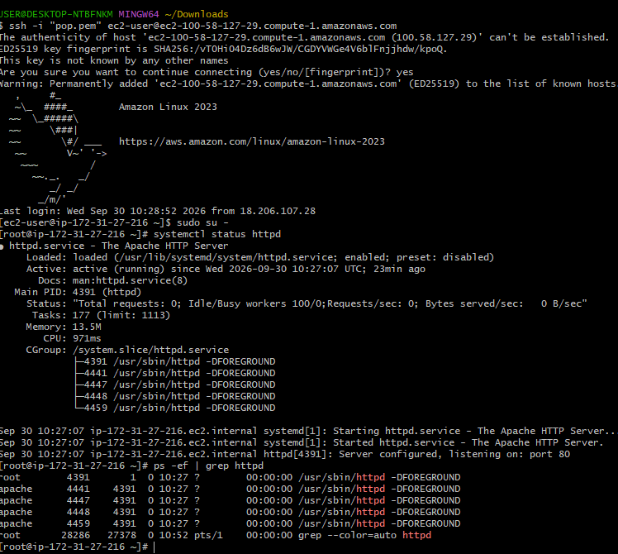
- Launch one EC2 using Ubuntu image and add a script in user data to install Nginx.
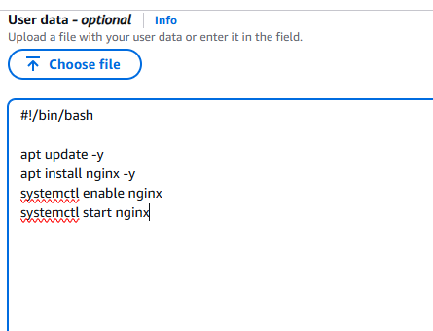
.
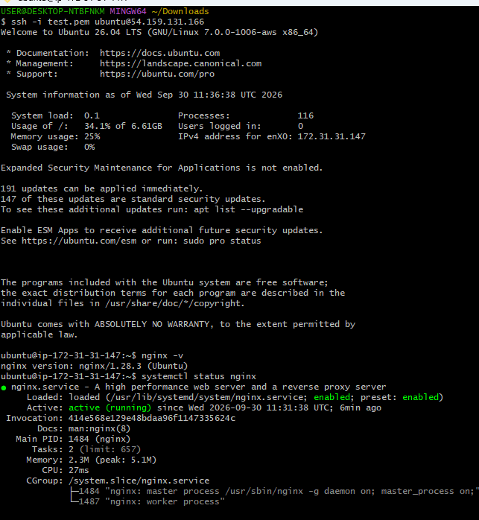
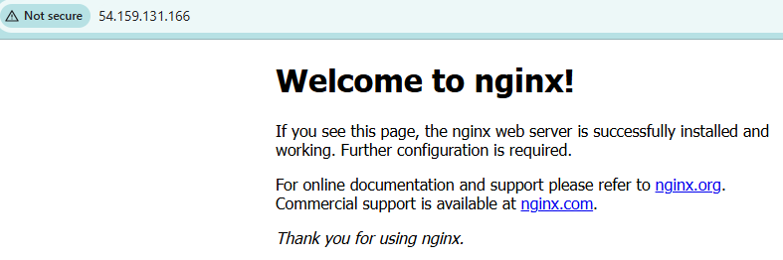
- Launch one Windows server and install Tomcat on Windows.
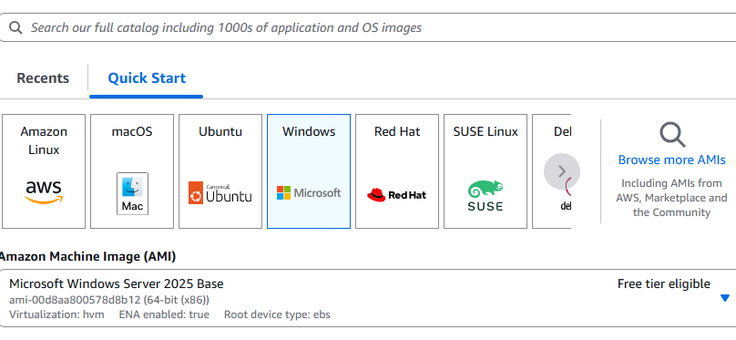
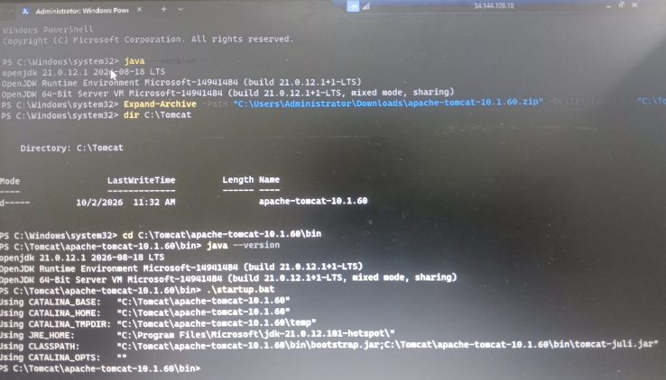
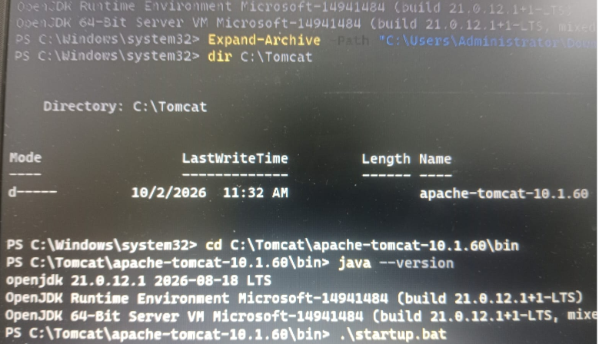
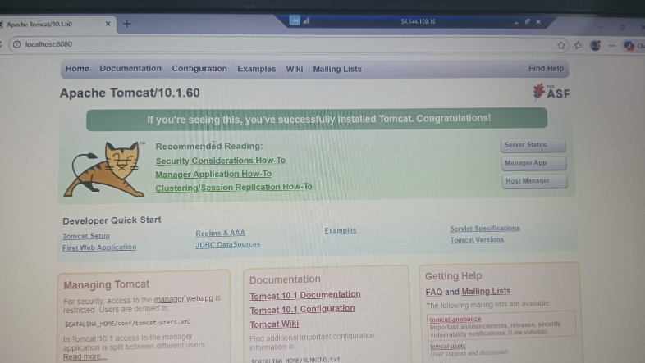
- Take a snapshot of the instance created in Task 1.
Purpose: To create a backup of the EC2 instance's EBS volume.
- Go to AWS Console → EC2 → Instances.
- Select the Task 1 Ubuntu instance.
- Open Storage → Root EBS Volume.
- Click Actions → Create snapshot.
- Enter description: Task-1-Ubuntu-Nginx-Snapshot
- Click Create snapshot.
- Go to EC2 → Snapshots and verify Status: Completed.

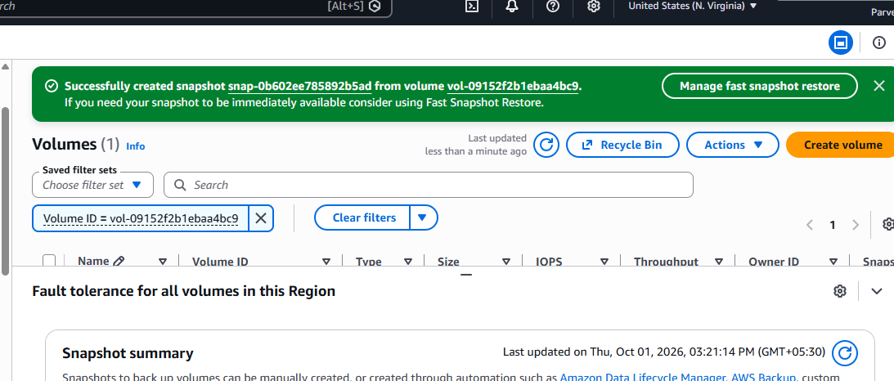
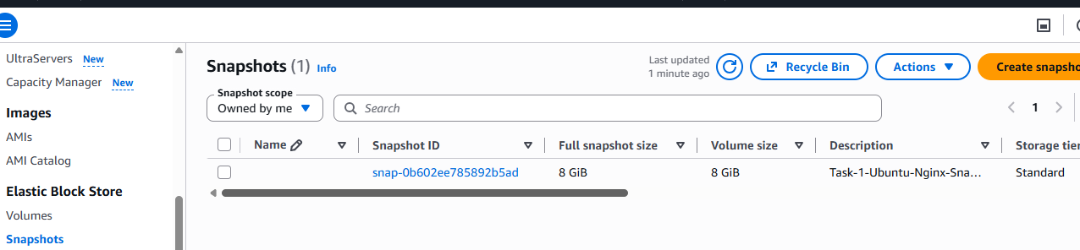
- Assign passwordless authentication for the EC2 created in Task 2.
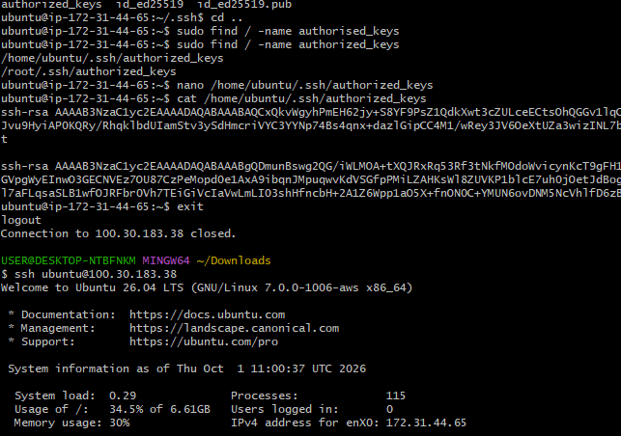
- Launch any EC2 using the spot purchasing option.
1) Go to EC2 → Instances.
2) Click Launch instance.
3) Scroll to Advanced details.
4) Find Purchasing option.
5) Select Spot Instances .
6) Configure the instance and click Launch instance.
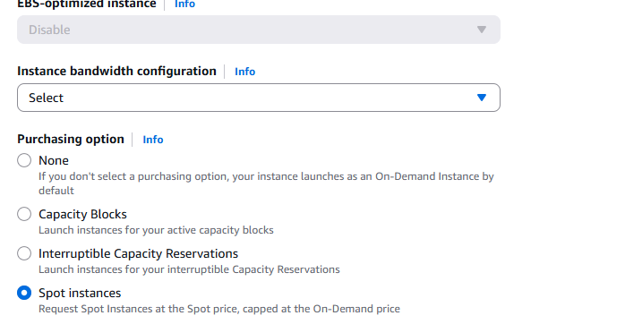
.
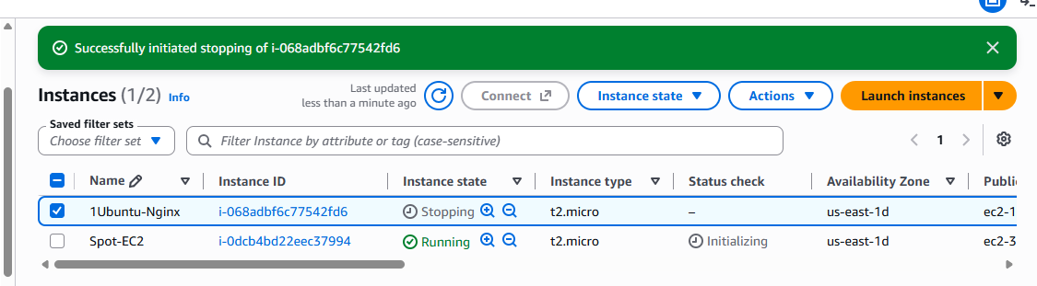
- Enable termination policy on the EC2 created in Task 2.
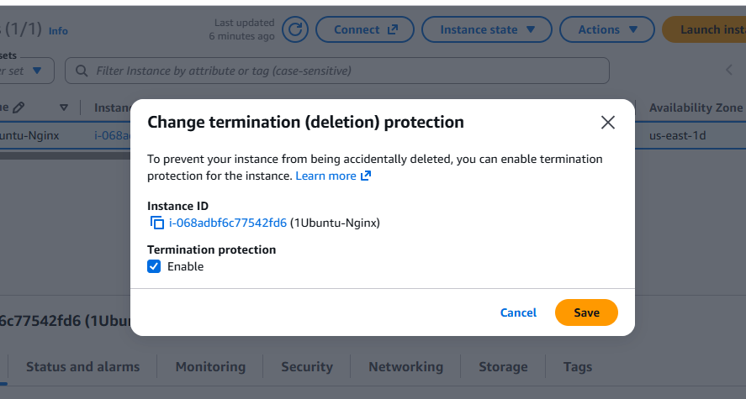
✅ EC2 instance selected
✅ Instance settings opened
✅ Termination protection enabled
✅ Saved successfully.
- Launch one EC2 using AWS CLI.
